21.17: 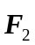is in the 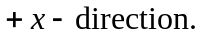
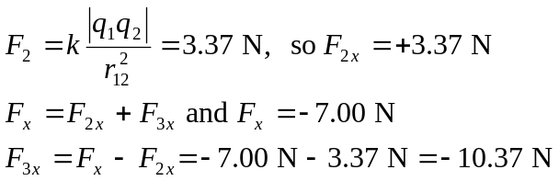
For 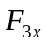 to be negative, 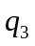 must be on the –x-axis.
